GRADE 7 ACCELERATED · UNIT 2 · LESSON 4  Approximating Irrational Numbers  Worksheet 7A.02.04 | Name_________________________  Date__________________________  Period________________________

1. Find the value of each. If there is no real value, write “no real value.”
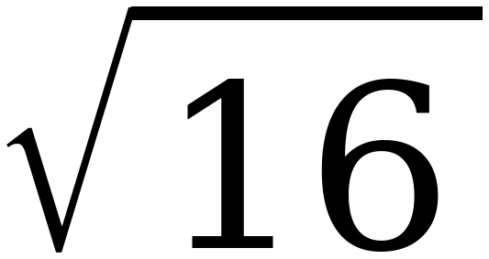 | 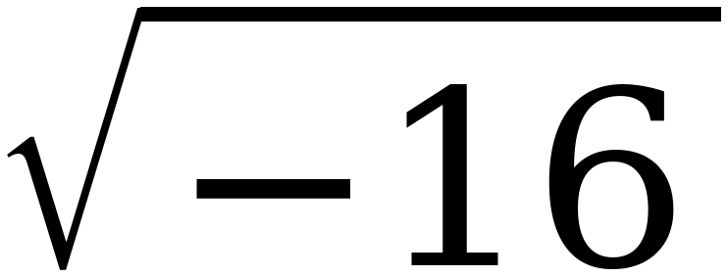 | 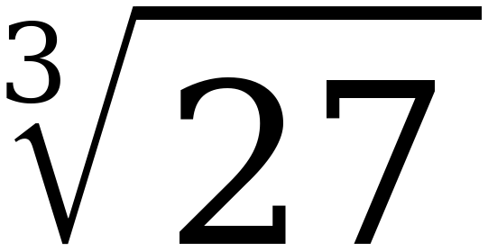 | 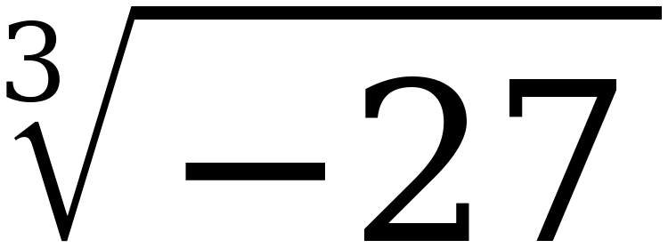

2. Which of the four in question 1 had no real value? Explain when that happens.

3. Select ALL of the numbers below that are irrational.
☐ | 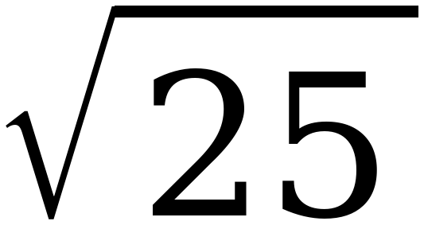 | ☐ | 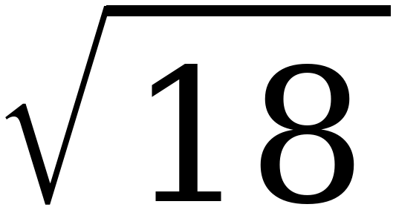
☐ |  | ☐ | 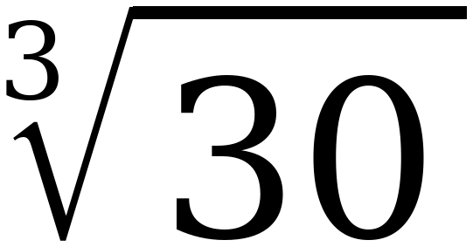
☐ | π | ☐ | 

Questions 4 and 5: name the perfect squares or cubes first, then the root.
4. 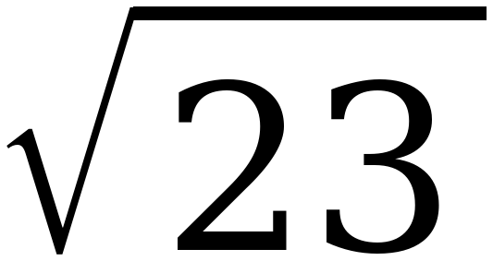
a. 23 lies between the perfect squares ______ and ______.

b. So the root lies between the integers ______ and ______.

c. The root is closer to ______.

5. 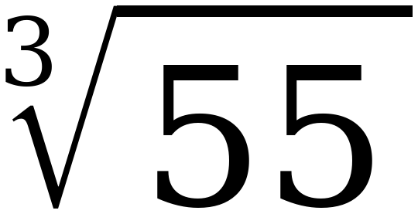
a. 55 lies between the perfect cubes ______ and ______.

b. So the root lies between the integers ______ and ______.

c. The root is closer to ______.

6. Approximate 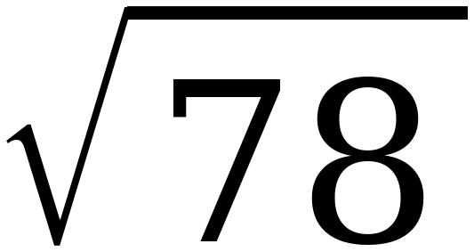 to the nearest tenth. Fill in the table, then decide.
Try | Result | How far from 78
8.8 × itself
8.9 × itself

To the nearest tenth, the value is ______________.
7. Approximate 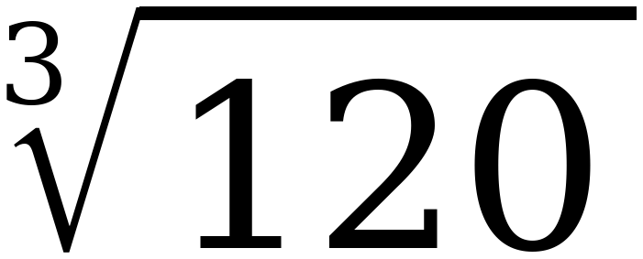 to the nearest tenth. Fill in the table, then decide.
Try | Result | How far from 120
4.9 cubed
5 cubed

To the nearest tenth, the value is ______________.
8. Use ≈ 8.83 to approximate each expression to the nearest tenth.

Expression | Approximate Value
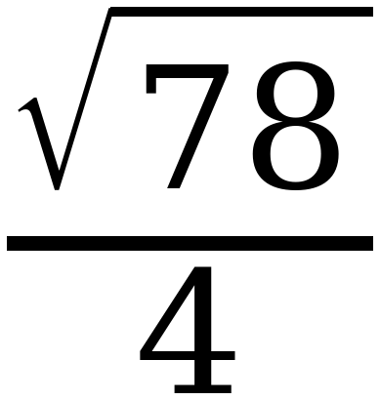
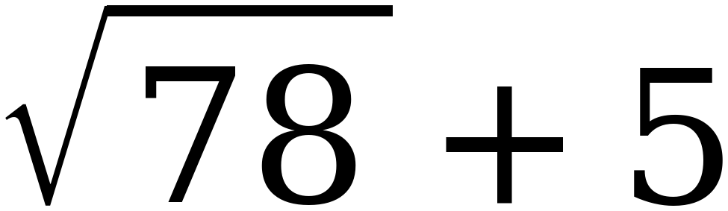
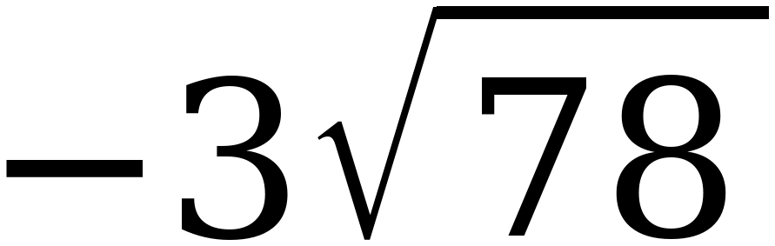

9. Approximate the value of each expression to the nearest tenth.

 | Expression | Approximate Value
A
B | 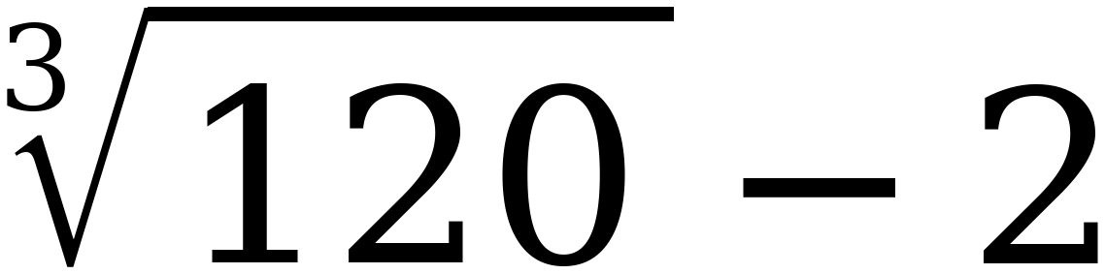
C | 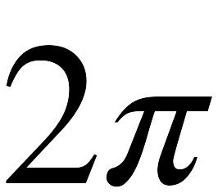
D | 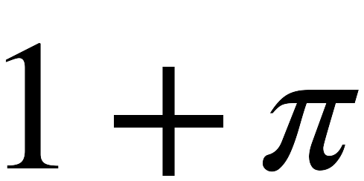

10. Plot and label A, B, C and D on the number line.
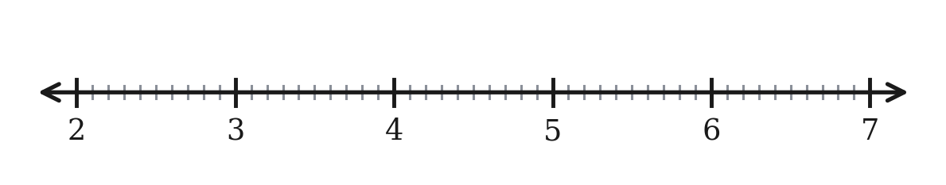
11. Priya says that because 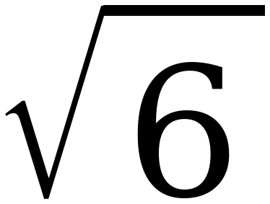 ≈ 2.4, the value of 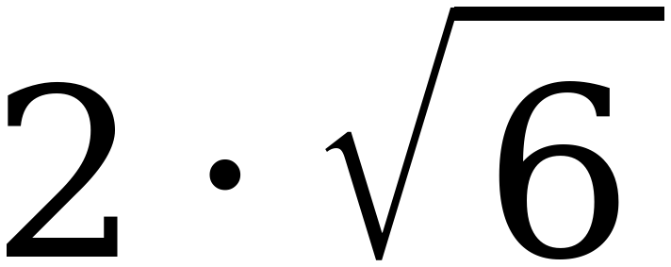 is 4.8. Her calculator says 4.9. Who is right, and what went wrong?

